Quotation Sheet
DKX4540 Carton Erector & Bottom Sealer
  Brand From the Quality  World of Mouth from service | 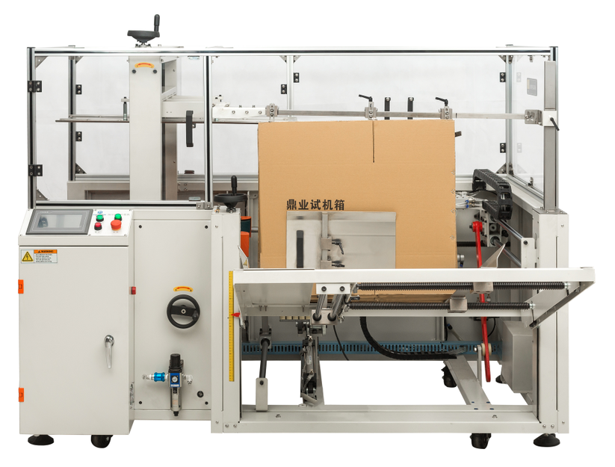
Model | DKX4540
Power supply | 220V/380V 50/60HZ
Max. packing dimension | 450(L)400(W)* 400(H) mm
Min. packing dimension | 200 (L)*150 (W)*400 (H) mm
speed | 1-10 box/min
Air source | ＞500L/min,0.4-0.8 MPa
Tape | W48mm. W60-75mm*L1000
Machine size | 2000 (L)*1900(W)*1450 (H)mm
Machine weight | 550 KG
Machine Deatail
Machine Diametion


